Coach Development Workshops 2017
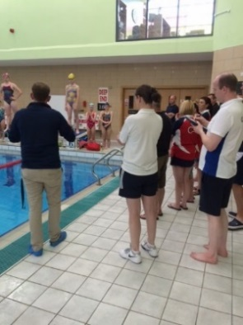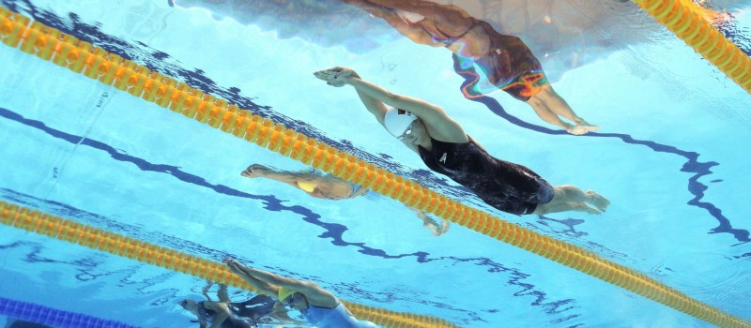
County Coaches Conference
Saturday 4th March (9.30am – 4.30pm) Wycombe Leisure Centre
Lindsay Dunn, England Programmes Officer
- This day will be a conference with places allocated to coaches selected by their county to be involved in the 2017 county 11 year old camps.
- There will be additional spaces available to book through the region for other interested level 1 and 2 coaches. Please express your interest through the booking form attached.
The day will cover,
- Effective communication
- The principles of planning
- Developing a race model
- RMAP land training exercises.

Sunday 5th March (9.30am – 4.30pm) K2 Leisure Centre, Crawley
Dan Cross, Head Coach, Thanet Swimming Club and Steve Greenfield, Head Coach Ryde SC and ASA Tutor
- This course will be for level 1 and level 2 coaches working with age group swimmers.
- Content will include; the theory of turns
- Planning to get the most out of each session and incorporating turns.
- Underwater work
- Practical session to include coaching turns and motivational session planning
Save the dates;
- Sunday 11th June Regional Coaches Conference, this will be for level 2 coaches selected to participate in the regional 12 year old camps and other interested level 2/3 coaches
- Sunday 18th June; Regional Open Water Camp. This will be an opportunity for coaches to learn more about open water swimming. This will involve a pool skills session, a workshop and an open water session.
To book your place please complete the booking form attached

Regional Coach Development Days March 2017
Booking Form
Please select the workshop that you wish to attend;
Saturday 4th March | County Coaches Conference, Wycombe Leisure Centre | 9.30am – 4.30pm  (lunch provided)
Sunday 5th March | Coach workshop – K2 Leisure Centre, Crawley | 9.30am – 4.30pm  (lunch provided)

Club Name
Coach 1 | Name:  Address:  Email:  Contact number:  Dietary requirements:
Coach 2 | Name:  Address:  Email:  Contact number:  Dietary requirements:
Coach 3 | Name:  Address:  Email:  Contact number:  Dietary requirements:
Cost: £20 per coach, £10 per coach from a Swim 21 Accredited club. SER affiliated clubs only. Applications from other regions will open two weeks before the relevant workshop.
Amount enclosed; £………….Please make cheques payable to ASA South East Region and forward the cheque and registration form to; Bryony Gibbs, ASA South Division Office, Castle Business Centre, Castle Road, Chelston Business Park, Wellington, TA21 9JQ

For any questions please contact Kristie Jarrett, Regional Club Development Officer; Kristie.jarrett@freedom-leisure.co.uk/ 07725201601

